**8. Paul: the last eyewitness**

**Reading: 1 Corinthians 15:3-7**

I gave you the message I received. I told you the most important truths: that Christ for our sins, as the Scriptures say; and that he appeared to Peter and then to the twelve apostles. After that, Christ appeared to more than 500 if the brothers and siters at the same time. Most of them are still living today, but some have died. Then he appeared to James and later to all the apostles. Last of all, he appeared to me.

**Thought about the reading**

This reading is from a letter which Paul wrote to the Christians who lived in a town called Corinth. He is reminding them of all the eyewitnesses who saw Jesus after he had risen from the dead.

After The Holy Spirit came down at Pentecost, more and more people decided to follow Jesus and the church began to grow. Some Jewish leaders did not like this. Paul was one of those who wanted to stop the church growing. He hated the Christians. He arrested them and put them in prison.

One day he was travelling to a town called Damascus to arrest more Christians, when Jesus appeared to him in a blinding light and spoke to him. Paul realised that he was wrong about the Christians, and he decided to follow Jesus too. God used him to tell the Good News to people who were not Jews.

Although Paul did not see Jesus before he went back to heaven, he says he is an eyewitness because God appeared to him on the road to Damascus. When he saw Jesus, he was sorry for the terrible things he had done wrong, and Jesus forgave him.

We have not yet seen Jesus, but he still wants us to be witnesses and to tell people the good news about him.

**Prayer**

Lord Jesus, thank you that you forgave Paul and made him your witness. Please make me your witness by the power of your Holy Spirit. Help me to tell other people the good news that you love them and died for them so they too can be forgiven.

Amen

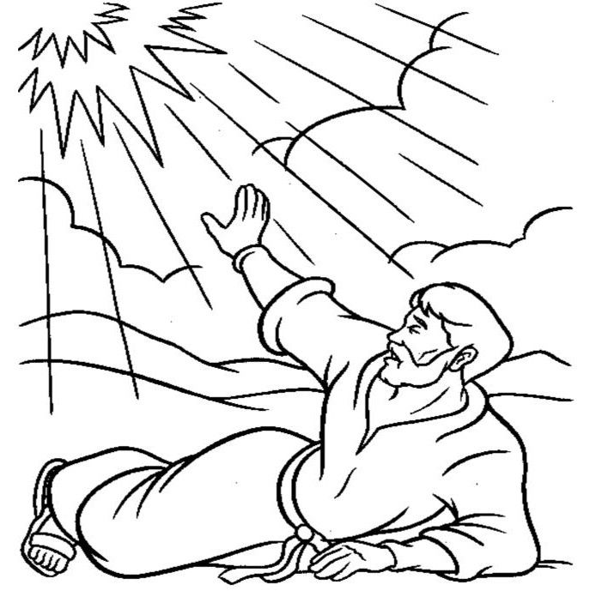

**Cambridge Causeway**

Summer 2021

Bible Study notes

**Eyewitnesses**

**8. Paul – the last eyewitness**

By Chrissy Cole